Tailored Messaging
Randomised trial results on
Risk-factor adjusted pop-ups

Tailored Messaging:
Randomised trial results on risk-factor adjusted pop-ups

What is the topic?
Pop-up messages are provided direct to players when they initiate a gambling session or upon a specified in-play trigger, with content designed to help players manage their gambling-related risks. Such messages can have a better chance of engaging players at an appropriate time than email based messaging, particularly given the large volume of emails commonly received.
Why is it important?
Targeted interventions with higher risk players have the potential to support safer gambling strategies without unduly affecting the experience of the majority of players. Challenges include identifying the best intervention groups, increasing impact, and evaluating results. Playtech Protect has been working with Swiss Casinos since 2023 in a series of randomised trials to improve one particular intervention: pop-up messaging. These trials build on a growing evidence base on the effectiveness of more personalised interventions, as we found with deposit limit setting in our 2020/21 research - see our Industry Research Brief Vol 1(2) - and RG Plus identified in their 2024 evidence review and focus group study on critical points for interaction in the customer journey.
What did the research do?
This research brief focuses on an A/B/C randomised trial that tested personalised messaging against generic messaging and a control group, primarily examining engagement rates with the messages and with responsible gambling tools, such as limit setting and self-exclusion. We will also briefly describe a prior A/B trial that tested pop-up messaging against a control group which examined changes in play behaviour. Message text can be found in the Appendix.
The A/B trial ran between December 2023 and January 2024, where players flagged as high risk by BetBuddy had a 50% chance of being assigned to the control group or to a pop-up message on their next log-in to any Playtech game. 261 messages were sent and 263 cases were identified where a message would have been sent but were withheld to drive the A/B test.
The A/B/C trial ran between September 2024 and February 2025, with 862 players involved. The selection criteria were intended to identify high spending, higher risk players, where an RG intervention might be particularly warranted. Specifically, we included all players with a net loss of CHF 2500+ (~US$ 2900 at the time) at the online casino in the last 30 days who were also identified as either high risk or moderate risk by BetBuddy. One third were randomly assigned to a one-off generic message intervention; one third to a personalised message plus a follow-up message 15+ days later if their losses remained high (45 day net loss of CHF 4000+; ~US$ 4500 at the time); and one third to a control group. Messages were personalised using the top category of risk factor identified by BetBuddy: Amount spent; Time spent; Account activity; and Other/Multiple risk factors, where the latter is effectively best understood as a mostly generic message.
What did the research find?
Immediate effect on players: No cessation in play, but moderation of same-day losses
In both trials, there was no visible immediate cessation of play in response to receiving the message. For instance, the number of players whose last observed day of play was the message due-date or the following days was not statisically different across the different trial arms (Fig. 1).
In the A/B trial that analysed player behaviours, the message group saw a meaningful moderation in same-day losses. Specifically, the median loss (excluding players with net wins) on the message due-date was CHF 200 for the message group (n=197) compared to CHF 269 for the control group (n=209), a 26% difference (0.02 p-value for testing equality of medians). Moderations in play continued weakly in the following two weeks, with slightly lower losses and play frequency among the message group, but not statistically significant at this sample size.
Fig. 1. Days between first message due date and most recent date we saw a player bet (A/B/C trial)
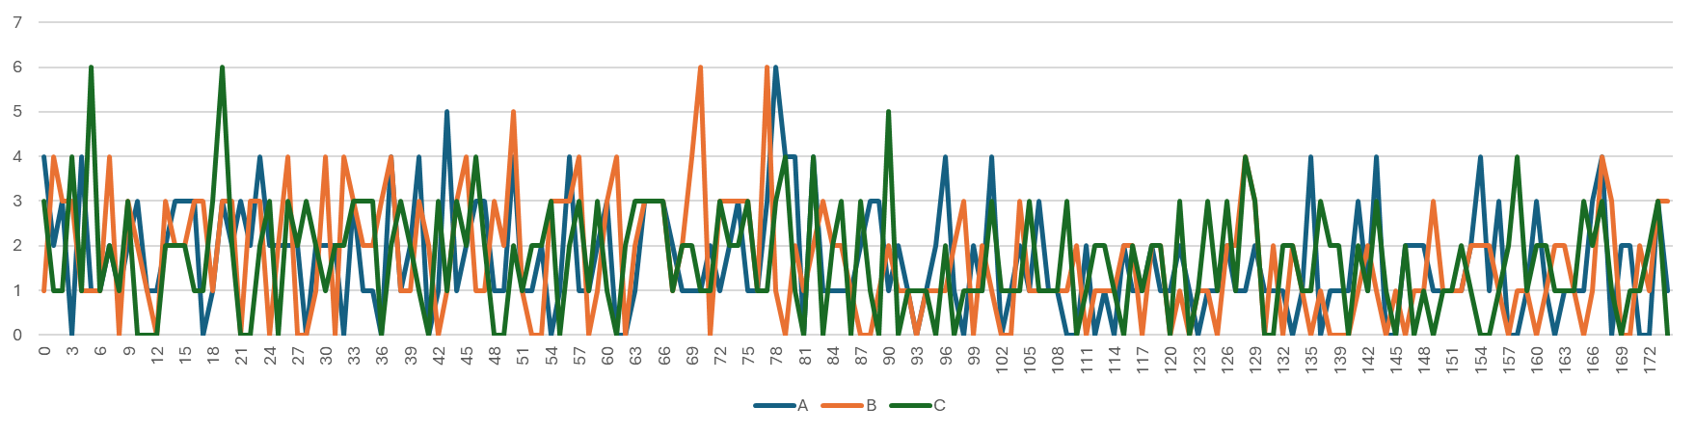
Note. No sustained difference between Groups A-C in Fig. 1 beyond random variation, indicating no material difference in full play cessation associated with the messaging intervention in the period analysed.
Message engagement: More personalised messages have higher click-through rates
Within Group C, three types of message were meaningfully personalised to a player’s highest risk factor (amount spent, time spent, account activity), compared to a fourth type of message which was fairly generic (where the player’s highest risk factor category represented a diverse mix of possible causes). The more personalised message pathways within Group C saw a much higher click-through rate to the responsible gambling tool (RG tool) limit setting landing page: 20.4% (n=152) vs 10.4% (n=135) after the first message and 37.4% (n=123) and 24.8% (n=101) cumulative click-through rate for the subset of players who qualified for the second message.
Message follow-up: The second message continued to reach new players
32% of Group C players engaged with either the first or second message (once they had a chance to receive both of them), compared to only 16% engagement after the first message. In other words, the second message continued to ellicit as much click-through to RG tools as the first message, suggesting that sustained messaging campaigns are worth exploring.
Increased limit setting in the personalised message group
Group C players were more likely to set a limit after the message 1 date than Groups A and B (p-value 0.03, odds ratio vs Group A 1.8x, n=647). This analysis excludes players who had set/changed limits prior to the message 1 date, at least as far as visible in our limit setting data beginning September 2024. Despite mild evidence of increased limit setting close to message receipt, the increased RG tool usage is identified more clearly when considering activity up to 7 days after the message due-date, suggesting that nudge effects can be delayed (a finding to be validated in further studies). However, RG tool engagement remained low compared to click-through rates, suggesting that alternative calls-to-action or landing pages could be worth testing.
Weak evidence of reduced self-exclusion in the personalised message group
Group C players were also slightly less likely to have any self-exclusion usage after the message 1 date than Groups A and B (p-value 0.12, odds ratio vs Group A 0.7x, n=813). The results are indicative only and are not statistically significant at current sample sizes (especially as self-exclusion rates are very low across all groups in the period), representing hypotheses that to test in the future, notably that more effective RG messages might reduce the need for self-exclusion.
What are the implications for industry and policy?
These trials collectively support the case for using tailored pop-up messaging, targeted to particular higher risk groups and personalised based on individual risk factors, in line with principles from behavioural economics. Such messages are light-touch interventions with correspondingly modest but worthwhile benefits in terms of short-term moderation in play and increased engagement with limit-setting tools. However, these are small-scale trials and replication/extension trials are recommended. The findings also cautiously suggest that more sustained messaging campaigns and alternative calls-to-action are worth exploring.

Appendix: Message Text
A/B trial: Intervention message
Hi there, <firstname>!
Are you aware of all of our responsible gambling tools?
We take our players’ well-being seriously and want to make sure you stay up to date with the tools we offer to keep track of your spending.
Would you like to check it out? [Option Yes | Option No thanks]

A/B/C trial: Generic message
Thank you for using our service, we really appreciate your loyalty.
Did you know that you can keep track of your gambling behaviour with our responsible gambling behavior tools?
Deposit Limit (hyperlink)
Loss Limit (hyperlink)
Gambling Break (hyperlink)
Session Time (hyperlink)
The well-being of our players is important to us. Fun should be at the center of your gambling experience. If this is no longer the case or you get into financial difficulties, our Customer Support is there for you 24/7 (Contact, 0800 CASINO) (hyperlink) or Chat (hyperlink).

A/B/C trial: First risk-factor personalised message (example for ‘amount spent’ risk factor)
You have lost more than CHF 2,500 at our online casino in the last 30 days.
If you’d like help tracking your play, we would particularly recommend setting a Loss Limit (hyperlink), as managing your spend helps to keep the games fun.
We also have other tools (hyperlink to main RG tools menu) to help protect yourself and those around you.
If you require assistance with this or you get into financial difficulties, our Customer Support is there for you around the clock (Contact, 0800 CASINO)

A/B/C trial: Follow-up risk-factor personalised message (example for ‘amount spent’ risk factor)
You have lost more than CHF 4,000 at our online casino in the last month and a half.
We recommend our players define a maximum gambling budget that does not restrict their everyday life. Setting a Loss Limit (hyperlink) helps many of our players with a similar profile keep the games fun.
Please use our responsible gambling behaviour tools to protect yourself and those around you from the effects of excessive gambling behaviour. Other tools include:
Deposit Limit (hyperlink)
Gambling break (hyperlink)
Session Time (hyperlink)
Fun should be at the center of your gambling experience. Take a gambling break if this is no longer the case.
If you require assistance with this or you get into financial difficulties, our Customer Support is there for you around the clock (Contact, 0800 CASINO)

Messages were translated into Swiss French and Swiss German as appropriate.

